

**Signals**

***Objective: In this lab you will create a LKM called “***signalex***”. The LKM will send signals from kernel mode to a user mode process called “siguser” which will be provided.***

***Reference:*** LKI/Lab11

1. The “siguser” process is capable of handling the signals SIGABRT, SIGTRAP, and SIGQUIT. The code for the user mode program is below:

**File(s) for this lab:**

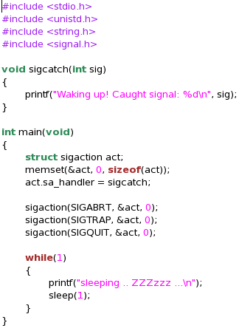

1. Your LKM “signalex” should send those signals to the user mode process using the send_sig_info() API call.
2. Finally, your LKM should pause for 5 seconds to allow those signals to process out of the signal queue before sending a signal using the force_sig() function.

